**  
 SRM Institute of Science & Technology, Delhi NCR**

**PYTHON PROGRAMMING**

**[15IT322E]**

Mini Project **:**

**Webmap – Mapping World Population**

By**:**

**MEHUL BHARGAVA**

**CSE-L**

**RA1711003030728**

**OBJECTIVE**

This mini project focuses on the population count of several countries of the world. It gives users a GUI of the world map, representing countries with three different colours red, yellow and green based on their population count either overpopulated or moderate population or normal population.

The three different colours representing the countries makes it easier for the users to understand the population condition and makes the map user friendly. It also have markers marking the locations of different volcanoes in the North America region. These markers are also in three different colours red, yellow and green based on the height of the volcanoes. It also pops out the height (in meters) of the volcanoes when we click on the marker thereby providing user friendly and attractive interface with the users.

A user can also zoom in and zoom out on the map and can move the map using the mouse. Map also displays names of the continents as we zoom out and when zoom in it shows names of countries and further zoom in displays the states and cities. It also provides a control layer on the top right corner for the users.

So, the main objective is to represent world population and some volcanoes on a world map providing attractive and very useful interface to the users.

**INTRODUCTION**

It is a project based on one of the main applications of Python that is web development, development of web applications, etc. Its code includes modules like folium and pandas and their various methods.

It gives users a GUI of world map, showing population of different countries in an interesting way and location of volcanoes in North America region.

The colours of countries on the map have three different shades red, yellow and green symbolizing if the country is overpopulated, moderately populated or controlled population. The country with over 20 million population is in red colour, the country with population between 10 million to 20 million is represented by yellow colour and the country with less than 10 million population is represented with green colour. These are standard colour representations are used in various applications. The volcanoes on the map are marked with circle shaped markers which will pop out their height (in meters) when clicked. They are also in different colours red, yellow and green based on their heights. Red colour is for those volcanoes with height above 3000 meters, yellow for those with height between 1000 to 3000 meters and green for height below 1000 meters. Map also displays names of continents, countries, states and cities by zooming in and zooming out. Map also have boundary lines that help uses to identify the countries easily. It also have a control layer to remove and again add the layers of population and volcanoes according to the users need and requirements.

It is a webmap having appreciable qualities and really useful for the users.

**SOFTWARE & HARDWARE REQUIREMENTS**

SOFTWARE Requirement:

1. PyCharm IDE, Atom IDE or any other code editor for code writing.
2. Google Chrome or any browser to open the webmap.
3. Install Python3 from its official website.
4. Install two python libraries pandas and folium.
5. Good internet connectivity.

HARDWARE Requirement:

1. Laptop or Computer.

**METHODOLOGY**

Before writing code create a folder anywhere on your computer and transfer json and text files into it, which contain the important data in them. Then open the IDE python editor and in the IDE open your folder which you have created.

Now write the code in it. In the code first import folium and pandas modules. Then using different methods and functions of folium and pandas retrieve the data from text files and json files about the population of different countries and volcanoes. Using loops and conditional statements set the colours of the markers and countries based on their data. Finally, using save() method save the program with a name and with the extension name .html. Now, in the Terminal of your IDE execute the program using the appropriate command and the html file will be automatically created in your folder which you have created.

Open the folder again and open the html file created with proper internet connectivity. The output is in front of you.

**MODULES USED**

In this mini projects two modules are used namely Folium and Pandas.

Folium: Folium is a python module that easily converts or Python code into CSS, JavaScript and HTML. It makes it easy to visualize data on a map. It enables binding of data on a map. It has several layers of maps and provides several methods and functions to create a webmap.

Pandas: Pandas is a fast, flexible and easy to use python module for data manipulation and visualisation. Here, I have used it to extract data from the text files.

**SOURCE CODE**

import folium  
import pandas  
  
data= pandas.read_csv("Volcanoes.txt")  
lat=list(data["LAT"])  
lon=list(data["LON"])  
elev=list(data["ELEV"])  
  
def color_producer(elevation):  
 if elevation<1000:  
 return 'green'  
 elif 1000<= elevation <3000:  
 return 'orange'  
 else:  
 return 'red'  
  
map=folium.Map(location=[23.11, 79.48], zoom_start=5, tiles="Stamen Terrain")  
fgv=folium.FeatureGroup("Volcanoes")  
  
for lt,ln,el in zip(lat,lon, elev):  
 fgv.add_child(folium.CircleMarker(location=[lt, ln], radius=6, popup=str(el)+ " m",  
 fill_color=color_producer(el), color='grey', fill_opacity=0.7))  
  
fgp=folium.FeatureGroup("Population")  
  
fgp.add_child(folium.GeoJson(data=open('world.json', 'r', encoding='utf-8-sig').read(),  
style_function=lambda x: {'fillColor':'green' if x['properties']['POP2005'] < 10000000  
else 'orange' if 10000000 <= x['properties']['POP2005'] < 20000000 else 'red'}))  
  
map.add_child(fgv)  
map.add_child(fgp)  
map.add_child(folium.LayerControl())  
  
map.save("Map1.html")

**OUTPUT & ITS SCREENSHOTS**

Map showing continents, countries and states. The countries are coloured on the basis of population. Here are some screenshots:

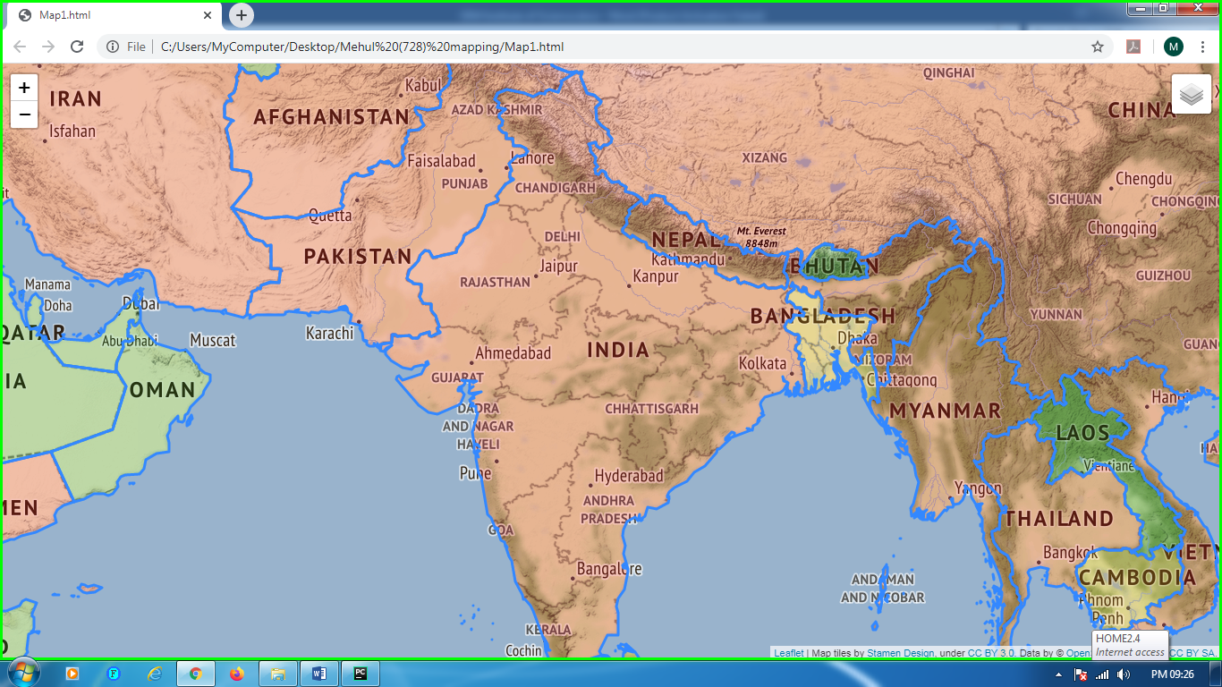

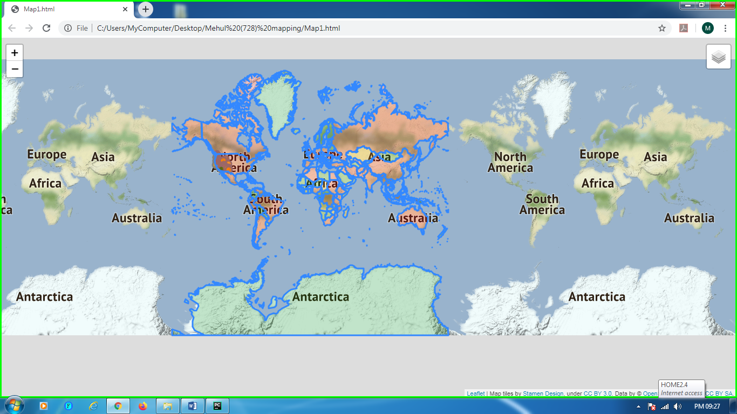

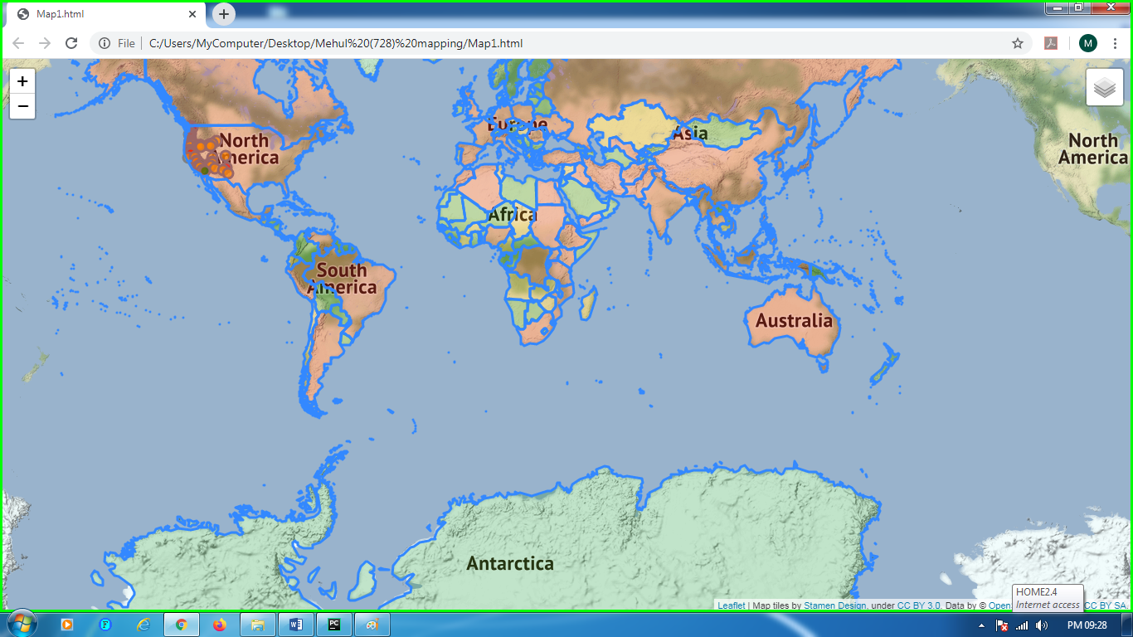

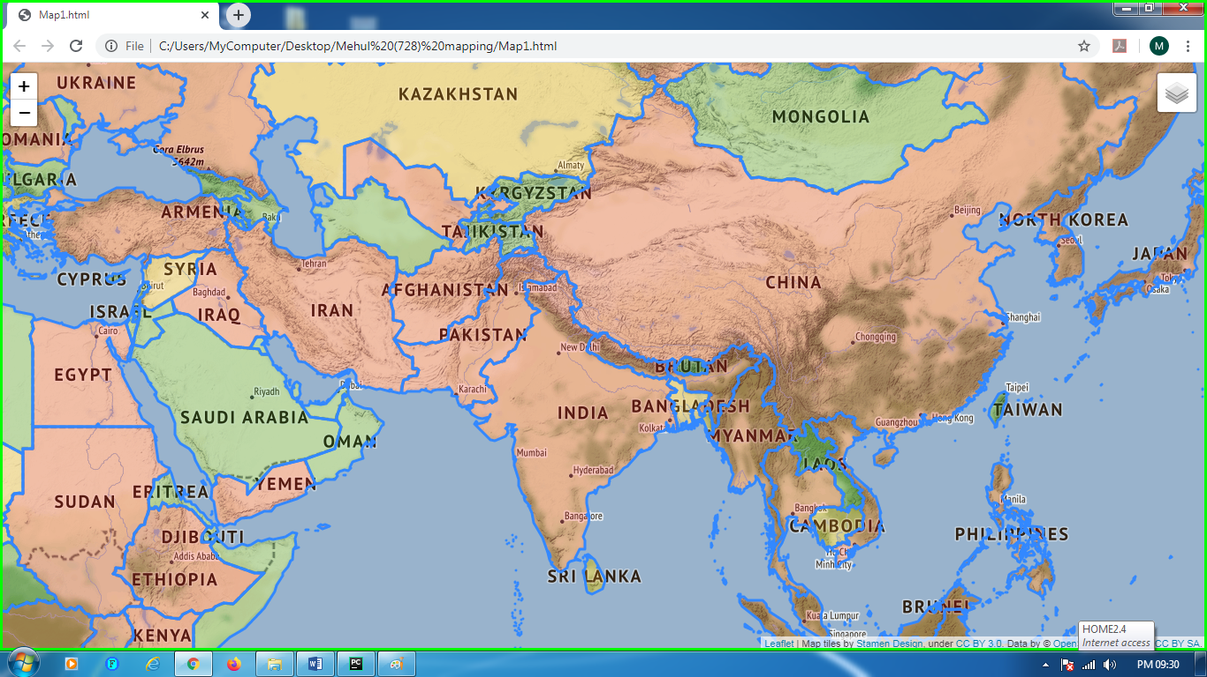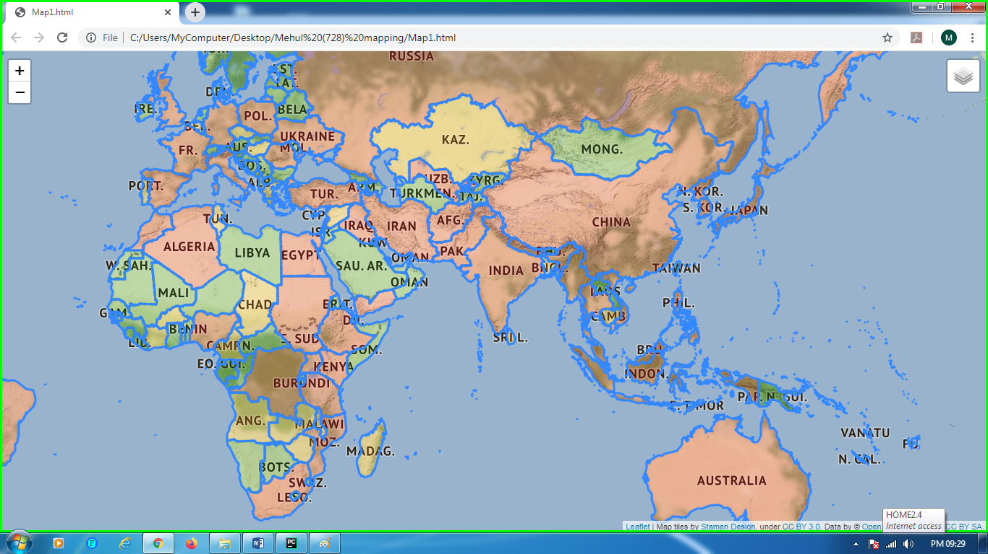

Map having Control Layer on the top right corner.

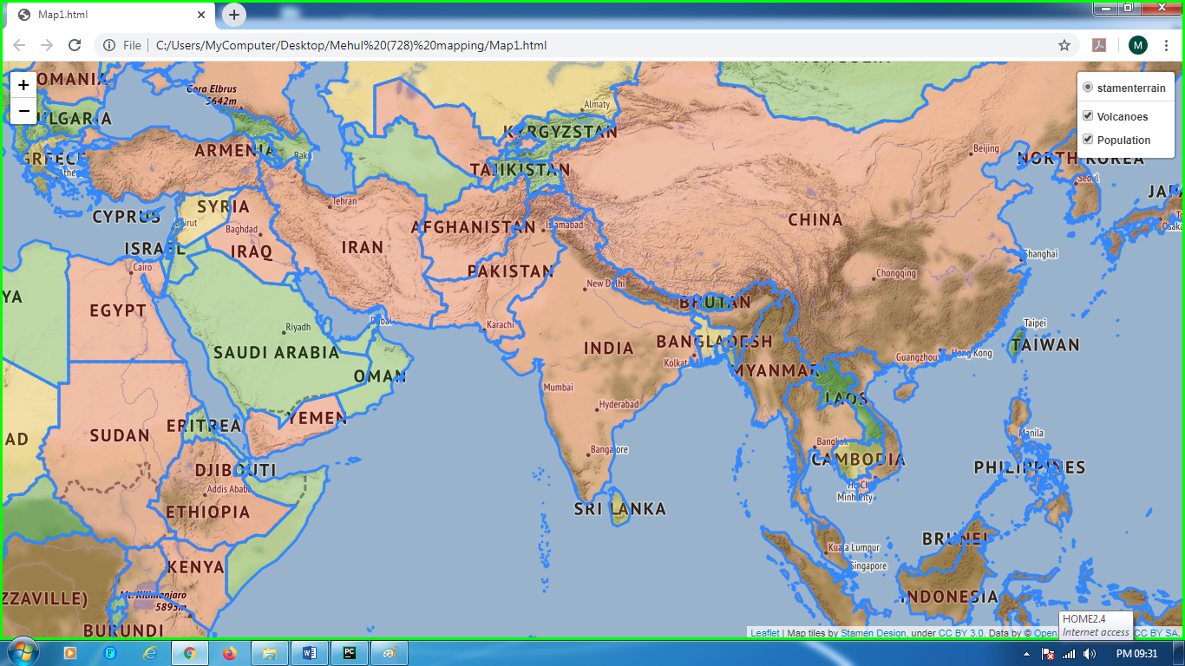

Map with circle markers showing locations of volcanoes.

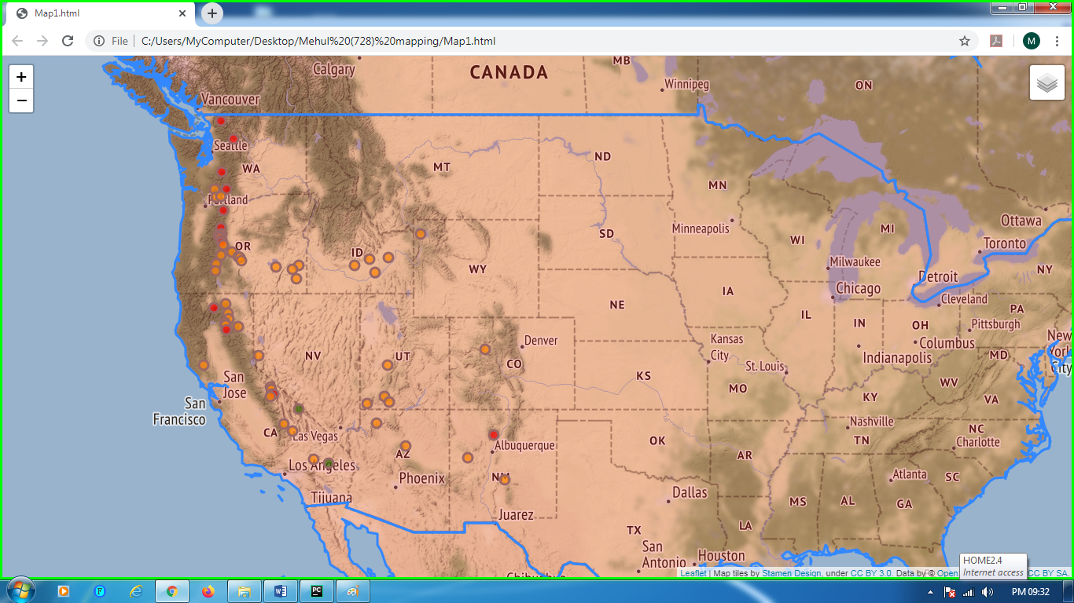

Map after removing population layer by using Control Layer option in the top right corner.

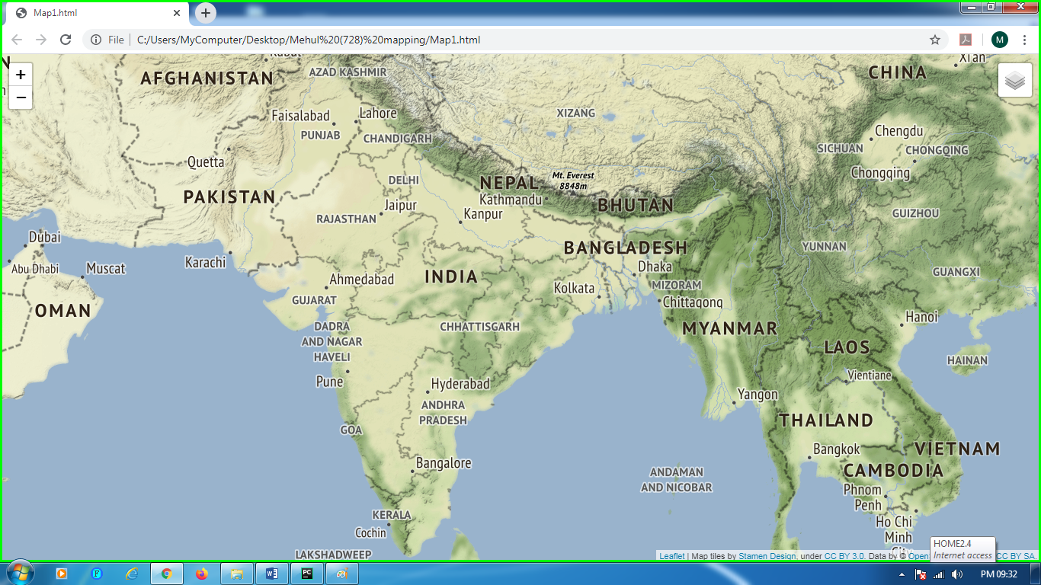

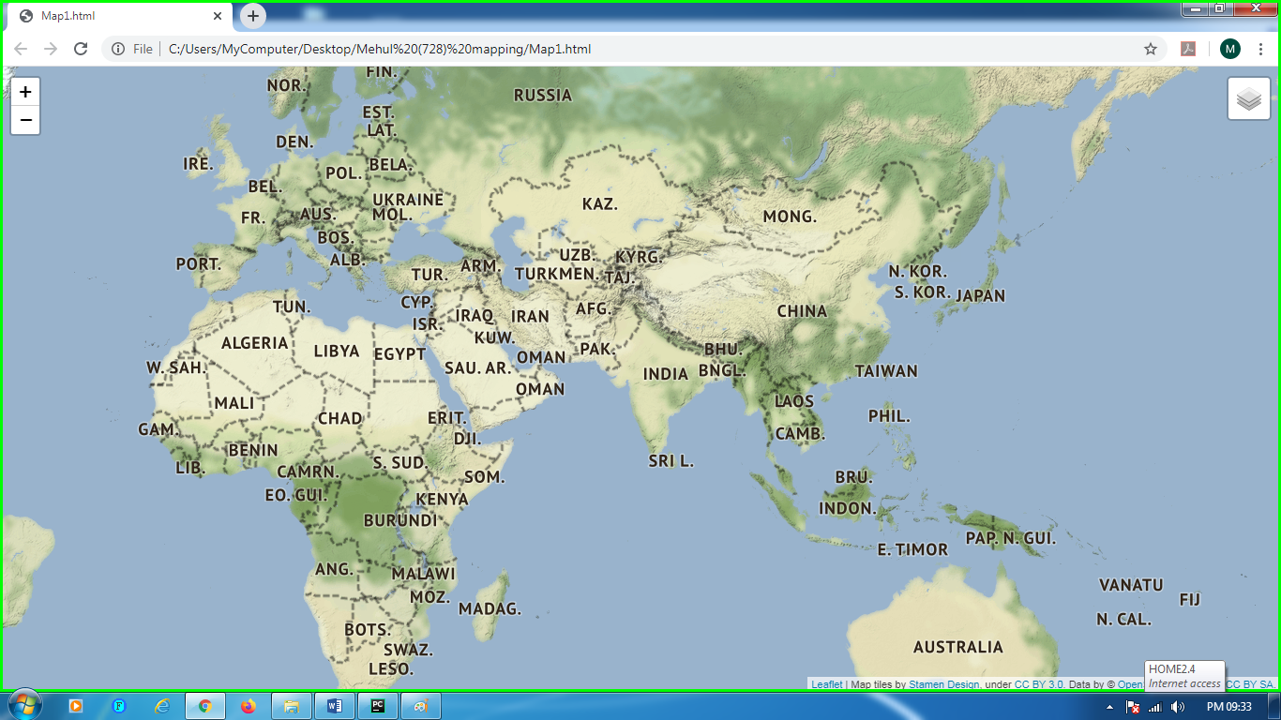

Marker showing height of the volcano by a popup message by clicking on the marker.

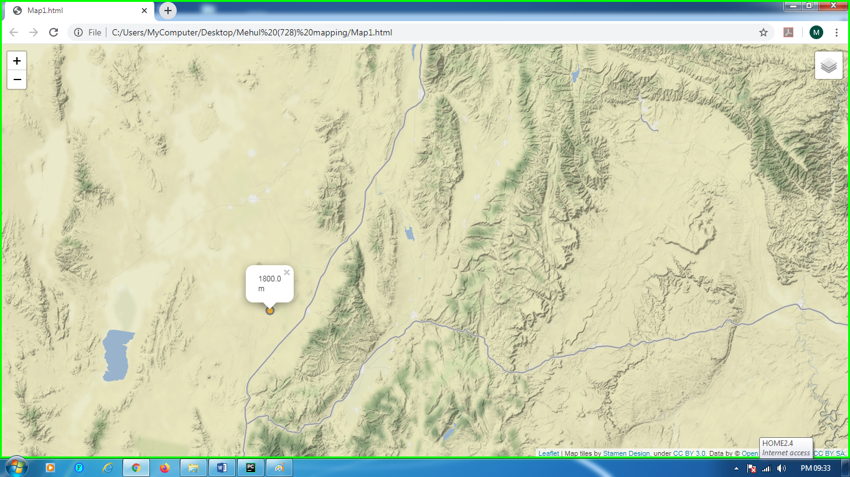

**CONCLUSION**

The problem for the users of finding the population conditions of various countries is solved by this project, they can view the population conditions in one map very easily. The project is a webmap displaying world population of different countries and displaying locations of some volcanoes with their heights in a really unique manner. It is providing users with an attractive and user friendly map. In the code modules like folium and pandas are used. It is also interactive with the user to use as it has control layer option. Hence, it is a simple, easy to use, easy to understand and user friendly project providing webmap.

**REFERENCES**

1. [**https://www.google.co.in/**](https://www.google.co.in/) **Google Chrome Browser**
2. <https://www.udemy.com/> Udemy Online Learning
3. <https://www.youtube.com/> Youtube

**THANK YOU!**

**MEHUL BHARGAVA**

**CSE-L**

**RA1711003030728**